**A**

**Project Report**

**on**

**PathoEase**

**Artificial Intelligence and Data Science**

**by**

***Paras Dwivedi (2101921630036)***

***Shashank Jha (2101921630049)***

***Arjun Tomar (2101921630011)***

***Utkarsh Pratap Singh (2101921640059)***

**Under the Supervision of**

**Mr. Satyam Singh**



**G.L Bajaj Institute of Technology and Management**

**Greater Noida, Uttar Pradesh**

**India-201306**

**Affiliated to**



**Dr. A.P.J. Abdul Kalam Technical University**

**Lucknow, Uttar Pradesh,**

**India-226031**

**December, 2023**

|  |  |
| --- | --- |
|  | **G.L BAJAJ INSTITUTE OF TECHNOLOGY & MANAGEMENT**  **GREATER NOIDA, UTTER PRADESH, INDIA- 201306.** |

# CERTIFICATE

This is to certify that the project report entitled “**PathoEase**” submitted by Paras Dwivedi (2101921630036) , Shashank Jha (2101921630049) Arjun Tomar (2101921630011) and Utkarsh Pratap Singh (2101921640059) to the **G.L BAJAJ INSTITUTE OF TECHNOLOGY & MANAGEMENT**, Greater Noida, Utter Pradesh, affiliated to Dr. A.P.J. Abdul Kalam Technical University Lucknow, Uttar Pradesh in partial fulfilment for the award of Degree of Bachelor of Technology in Computer science & Engineering is a bonafide record of the project work carried out by them under my supervision during the year 2023-2024.

|  |  |
| --- | --- |
| **Mr. Satyam Singh**  **Assistant Professor**  **Deptt. of Applied CSE** | **Dr. Naresh Kumar**  **Dean**  **Deptt. Of Applied CSE** |

|  |  |
| --- | --- |
|  | **G.L BAJAJ INSTITUTE OF TECHNOLOGY & MANAGEMENT**  **GREATER NOIDA, UTTER PRADESH, INDIA- 201306.** |

# ACKNOWLEDGEMENT

We have taken efforts in this project. However, it would not have been possible without the kind support and help of many individuals and organizations. We would like to extend our sincere thanks to all of them.

We are highly indebted to **Mr. Satyam Singh** for her guidance and constant supervision. Also, we are highly thankful to them for providing necessary information regarding the project & also for their support in completing the project.

We are extremely indebted to **Dr. Naresh Kumar**, Dean, Department of Applied Computer Science and Engineering, G.L BAJAJ and **Mr. Satyam Singh**, Department of Computer Science and Engineering, G.L BAJAJ for their valuable suggestions and constant support throughout our project tenure. We would also like to express our sincere thanks to all faculty and staff members of Department of Computer Science and Engineering, G.L BAJAJ for their support in completing this project on time.

Our thanks and appreciations go to our friends in developing the project and all the people who have willingly helped me out with their abilities.

Paras Dwivedi

Shashank Jha

Arjun Tomar

Utkarsh Pratap Singh

# ABSTRACT

This project addresses the challenges inherent in the current healthcare landscape, focusing on the cumbersome process of accessing and scheduling pathology tests. The absence of a centralized and user-friendly platform leads to inefficiencies for both users and pathology clinics. The project's goal is to create a streamlined solution that enhances user experience by centralizing test information, simplifying appointment scheduling, and optimizing clinic operations. Through the implementation of secure password hashing with Bcrypt and efficient database interactions using SQLAlchemy, the project ensures robust security and system flexibility. The choice of tools, including Flask, SQLite, and JavaScript, underscores a commitment to a responsive and user-friendly interface. Overall, this project aspires to transform pathology test management, fostering accessibility, efficiency, and user satisfaction in healthcare practices.

**CONTENTS**

**Title Page**

**CERTIFICATE**  ii

**ACKNOWLEDGEMENT** iii

**ABSTRACT** iv

**CONTENTS** v

**LIST OF TABLES** vii

**LIST OF FIGURES** viii

**CHAPTER 1: INTRODUCTION**

1.1 Aim and Objective 01

1.2 A Little Background 01

1.3 Limitation 01

1.4 Motivation 01

1.5 Statement of Problem 02

1.6 Organization of Report 02

**CHAPTER 2: LITERATURE REVIEW**

2.1 Related Literature Review 0 4

2.2 Literature Survey 05 ..

**CHAPTER 3: PROBLEM DESCRIPTION**

3.1 Description of Problem 08

3.2 Problem Statement 08

3.3 Depiction of Problem Statement 08

3.4 Objectives 09

**CHAPTER 4: PROPSED WORK**

4.1 Introduction 11

4.2 Proposed Methodology 12

4.3 Description of Each Step 12

**CHAPTER 5: SYSTEM DESIGN**

5.1 Functional Specifications 14

5.2 Structural and Dynamic Modelling of System 16

5.3 Detail Block Diagram 19

**CHAPTER 6: IMPLEMENTATION**

6.1 Experimental Setup 20

6.2 PathoEase Outlook 22

**CHAPTER 7: PERFORMANCE MEASURES**

7.1 Performance Measures 27

**CHAPTER 8: CONCLUSION AND FUTURE SCOPE**

8.1 Conclusion 29

8.2 Future Scope 29

**REFERENCE**

**List of Tables**

**Table Title Page**

7.1 User Engagement Metrics TBD

**LIST OF FIGURES**

**Figure Title Page**

3.1 Depiction of Problem Statement 21

5.1 Level 0 DFD 27

5.2 Higher Level DFD 28

5.3 Class Diagram 29

5.4 Use Case Diagram 30

5.5 Interaction Diagram 30

5.6 State/Activity Diagram 31

5.7 Detail Block Diagram 32

6.1 Home Page 26

6.2 Main Login Page 28

6.3 User Login Page 30

6.4 Pathology Login Page 32

6.5 User Signup Page 33

6.6 User Home Page 33

6.7 Search Pathologies Page 33

6.6 Search Results Page 33

**CHAPTER 1**

**INTRODUCTION**

* 1. **AIM AND OBJECTIVE**

The PathoEase project sets out to revolutionize healthcare accessibility by creating a centralized and user-friendly platform for pathology testing. The overarching aim is to address the current challenges faced by individuals in accessing and scheduling pathology tests, while simultaneously streamlining the operations of pathology clinics. The project's objectives include the development of an intuitive web application that serves as a centralized hub connecting users and clinics. This involves enhancing user experience through a user-friendly interface, streamlining clinic operations with dedicated dashboards, and promoting health awareness. Security measures will be implemented to ensure the confidentiality of user data. Additionally, the project aims to future-proof the platform by designing it with scalability and flexibility, allowing for potential enhancements such as the integration of telehealth services, AI-driven recommendations, and wearables. The ultimate goal is to create a comprehensive solution that not only meets current needs but also evolves to embrace future advancements in healthcare technology.

**1.2 A LITTLE BACKGROUND**

**1.2.1 History**

The inception of this idea was through a hackathon held in 2021 with the theme of healthcare. While brainstorming for project ideas a gap in the market was found. This gap was for an aggregator of pathologies that could show the user relevant pathologies offering the desired tests along with their prices. Recognizing the persistent challenges individuals faced in navigating the intricacies of pathology testing and appointment scheduling, a transformative solution was envisioned. The development of PathoEase was driven by the desire to bridge the gap between users seeking timely and efficient healthcare services and pathology clinics grappling with operational inefficiencies.

**1.2.2 Need**

This effort is a response to the pervasive issues that exist in the present healthcare environment, particularly with regard to pathology test scheduling and accessibility. The shortcomings of the current system are evident in the inefficiencies in test discovery, as patients struggle to swiftly choose pertinent pathology tests. Furthermore, pathology clinics face operational challenges associated with scheduling, which result in inefficiencies in their general operations. These problems are made worse by the lack of a consolidated, easily navigable platform, which leads to a disjointed experience for both patients and clinics. In addition, the project tackles the more general issue of low accessibility and awareness, aiming to encourage people to take charge of their health. The proposed solution seeks to improve the operational efficiency of pathology clinics while streamlining the user experience to make it easier for people to get pathology evaluation.

**1.3 LIMITATION**

Currently, the healthcare landscape faces challenges in providing a seamless and user-friendly platform for individuals seeking pathology tests. The absence of a centralized system contributes to inefficiencies, making it cumbersome for patients to discover and schedule relevant tests. Pathology clinics, operating without a unified platform, encounter difficulties in managing appointments efficiently, leading to disruptions in their services. This lack of integration and accessibility not only hampers the overall user experience but also impedes the operational effectiveness of pathology clinics. Furthermore, there is a scarcity of awareness and accessibility, hindering individuals from proactively engaging in healthcare practices. In essence, the existing market limitations revolve around fragmentation, inefficiency, and a lack of user-centric solutions, creating a pressing need for a comprehensive and integrated platform to address these challenges. Moreover, the current healthcare system's disjointed nature contributes to delays and confusion in the diagnostic process, potentially impacting patient outcomes. The absence of a centralized repository for pathology information leads to scattered records, making it harder for healthcare providers to access comprehensive patient histories.

**1.4 MOTIVATION**

The motivation behind this project stems from a deep-seated commitment to improving healthcare accessibility, efficiency, and patient outcomes. Recognizing the challenges individuals face in navigating the complex landscape of pathology tests and appointments, coupled with the inefficiencies experienced by pathology clinics, our project seeks to bridge these gaps. The motivation is rooted in the belief that a centralized, user-friendly platform can empower individuals to take charge of their health by easily accessing and scheduling pathology tests. Simultaneously, the project aims to enhance the operational efficiency of pathology clinics, contributing to an overall improvement in the healthcare experience. The desire to create a positive impact on both individual well-being and the healthcare system as a whole serve as the driving force behind the initiation of this project.

**1.5 STATEMENT OF PROBLEM**

In the current healthcare landscape, the complex and disjointed process of accessing pathology tests creates significant challenges for both users and clinics. The absence of a centralized platform leads to inefficiencies, causing delays and frustration. This project seeks to revolutionize pathology test scheduling by introducing a user-friendly solution.

**1.6 ORGANIZATION OF REPORT**

**Literature Review**

Establish the project's context within the broader scope of healthcare technology and identify key findings, successful models, and potential gaps in the current literature along with reviewing existing literature on healthcare management systems, pathology test scheduling, and user-centric platforms.

**Problem Formulation**

Articulate the specific challenges faced by individuals and pathology clinics in the current pathology test scheduling process and discuss user pain points, operational inefficiencies, and the impact on proactive healthcare practices.

**Proposed Work**

Present the vision and goals of the project, emphasizing how it aims to address the identified challenges and outline the key features and functionalities of the proposed platform while highlighting the innovative aspects that set this project apart from existing solutions.

**System Design**

Provide an overview of the architecture and design considerations for the proposed platform and discusses key components, data flow, and user interfaces.

**Implementation**

Details the step-by-step process involved in creating PathoEase, emphasizing the challenges encountered during the implementation phase and their proposed solutions in development.

**Result Analysis**

Present the outcomes and performance metrics of the implemented platform and analyse user feedback, system responsiveness, and any improvements observed along with showcasing the effectiveness of the solution in addressing the identified challenges.

**Conclusion and Future Scope**

Summarize the key findings and achievements of the project and discuss any limitations encountered and lessons learned during the project while outlining potential areas for future enhancements and expansion of the platform.

**CHAPTER 2**

**LITERATURE REVIEW**

**2.1 RELATED LITRATURE REVIEW**

This literature review provides a comprehensive insight into the landscape of healthcare appointment scheduling platforms, delving into various facets such as existing solutions, motivational factors, limitations in the market, and technological interventions.

1. Existing Healthcare Appointment Scheduling Platforms:

* Exploration of current platforms facilitating healthcare appointment scheduling.
* Analysis of key features including user profile creation, appointment search filters, and communication tools.
* User feedback indicates varying degrees of success, with common concerns revolving around the ease of use, accessibility, and the need for centralized information.

1. Motivation behind Healthcare Appointment Scheduling Projects:

* Identification of the motivating factors prompting the development of efficient appointment scheduling systems.
* Consideration of user and clinic perspectives to understand the key challenges and opportunities in the healthcare appointment scheduling landscape.
* Exploration of the need for a user-friendly, centralized platform to enhance accessibility and streamline the appointment process.

1. Limitations in the Existing Market:

* Examination of the shortcomings and limitations of current healthcare appointment scheduling systems.
* Identification of challenges faced by users and clinics, such as inefficiencies, lack of centralization, and poor user experience.
* Understanding the gaps in the market that the project aims to address and overcome.

1. Statement of Problem:

* Articulation of the specific challenges and problems within the healthcare appointment scheduling landscape.
* Identification of inefficiencies, lack of centralization, and poor user experience as key problems to be addressed.
* Clear definition of the problem statement as a foundation for the proposed solution.

1. Motivation behind the Project:

* In-depth analysis of the driving factors that led to the initiation of the healthcare appointment scheduling project.
* Exploration of the desire to enhance user experience, streamline appointment processes, and improve overall operational efficiency for pathology clinics.
* A comprehensive understanding of the project's overarching goals and motivations.

1. Conclusion and Future Scope:

* A concise summary of the literature review, highlighting key insights and findings.
* Discussion of potential future developments, innovations, and trends in healthcare appointment scheduling.

**2.2 LITERATURE SURVEY**

2.2.1 *Published criteria for evaluating health related web sites Paul Kim, Thomas R Eng., Mary Jo Deering, Andrew Maxfield Date:12 December 2023*

The number of medical information web sites is increasing. The quality of such websites is highly variable, difficult to assess and are published by a variety of bodies such as government institutions, consumer and scientific organizations, patients’ associations, personal sites, health provider institutions, commercial sites, etc [1]

The large volume of health information resources available on the internet has great potential to improve health, but it is increasingly difficult to discern which resources are accurate or appropriate for users [2]. Because of the potential for harm from misleading and inaccurate health information, 9–14 many organisations and individuals have published or implemented criteria for evaluating the appropriateness or quality of these resources. [4]

Results suggest that many authors agree on key criteria for evaluating health related web sites, and that efforts to develop consensus criteria may be helpful. The next step is to identify and assess a clear, simple set of consensus criteria that the general public can understand and use.

The most frequently cited criteria for evaluating health-related information on the web include:

Content. Design and aesthetics of the site, Disclosure of authors, sponsors, or developers, Currency of information, Authority of the information source, Ease of use.

Criteria related to confidentiality and privacy were only cited by one author

Consensus regarding critical criteria for evaluation of web-based health information seems to be emerging.

The results indicate that many authors agree on key criteria for evaluating health-related websites.

The passage suggests that efforts to develop a set of key criteria may be helpful in ensuring a standardized and comprehensive approach to evaluating the quality of health information on the web. [5]

**2.2.2 Book Lab Test Online or Visit Offline? What’s Better? Drgulati**

**First Online: 20 May 2023**

Convenience

One of the primary advantages of “book lab test online” is the convenience it provides. With online booking, you can schedule your lab test at any time, from anywhere, without having to visit the lab in person. This is especially beneficial for individuals who live far away from the laboratory or have busy schedules. You can choose a suitable date and time, and the laboratory will send you a confirmation of your appointment.

On the other hand, visiting a lab in person can be time-consuming and inconvenient. You have to take time out of your busy schedule to go to the lab, wait in line, and fill out paperwork. Additionally, if you live far from the laboratory, you may have to spend time and money on transportation.

Accuracy

Another benefit of “book lab test online” is the result accuracy. When you book a test online, you can be sure that the information you provide is accurate, and that the lab will have all the necessary information to conduct the test. This reduces the risk of errors and ensures that you get accurate results.

Cost

"Book lab test online" can be cost-effective compared to visiting a lab in person. Many Diagnostic Labs offer discounts and special offers for online bookings, which can save you money. Additionally, online booking eliminates the need to spend money on transportation, which can be a significant expense, especially if you live far away from the lab. When you visit a lab in person, you may have to spend money on transportation, parking, and other expenses. [3]

**2.2.3 The Internet’s Challenge to health care provision Coiera, E. (1996)**

The challenge posed by the Internet to the provision of healthcare. The rapid growth of the Internet as we approach the end of the millennium marks a significant moment, ushering in the long-anticipated information age. However, the medical profession is largely unprepared for the profound impact of this transformation [6], both in terms of participation and understanding its consequences for clinical practice. The evolving nature of information delivery has extensive implications for healthcare, necessitating urgent dialogue within the profession to grasp the effects of communication and information technologies on healthcare provision. While some segments of the profession are already exploring these technologies, it is crucial to recognize that the implications of the Internet go beyond the technology itself. There is an immediate need to thoroughly examine how the Internet will shape the future of medical practice.

Characteristics of Pathological Booking Websites:

Deceptive Marketing Tactics: Pathological booking websites are known for employing deceptive marketing strategies to attract users. This may include false advertising, fake reviews, and manipulated ratings to create an illusion of legitimacy.

Hidden Fees and Unfair Practices: Many pathological booking websites are notorious for incorporating hidden fees and unfair business practices. Users may find themselves subjected to unexpected charges, undisclosed terms, and conditions that heavily favour the platform.

Poor Customer Service: Pathological booking websites often exhibit poor customer service, making it challenging for users to resolve issues or obtain refunds. This lack of support can lead to frustration and dissatisfaction among consumers.

Impact on Consumers:

Financial Loss and Fraud: Users of pathological booking websites are at risk of financial loss due to hidden fees, unauthorized charges, or fraudulent activities. Research has documented cases where consumers have fallen victim to scams, resulting in substantial financial setbacks.

Negative Emotional Impact: The deceptive practices of pathological booking websites can have a negative emotional impact on consumers. Frustration, stress, and a sense of betrayal may accompany the experience, affecting overall well-being.

Trust Erosion: Engaging with pathological booking websites can erode consumer trust in online platforms. This loss of trust extends beyond the specific booking site, potentially influencing users' perceptions of the entire online marketplace.

Regulatory Measures and Consumer Protection:

Legal Frameworks: Researchers and policymakers emphasize the need for comprehensive legal frameworks to regulate pathological booking websites. This includes measures to address deceptive advertising, enforce transparent business practices, and penalize fraudulent activities.

Enhanced Cybersecurity Measures: Strengthening cybersecurity measures is crucial to protect consumers' personal and financial information from being compromised. Improved authentication processes and encryption methods can contribute to a safer online environment.

Public Awareness Campaigns: Educating the public about the risks associated with pathological booking websites is essential. Public awareness campaigns can empower consumers to make informed decisions and recognize warning signs of deceptive practices.

**CHAPTER 3**

**PROBLEM DESCRIPTION**

**3.1 DESCRIPTION OF PROBLEM**

In the current healthcare ecosystem, the intricacies of accessing and scheduling pathology tests have evolved into a cumbersome and time-consuming process. The absence of a centralized and user-friendly platform exacerbates inefficiencies, causing disruptions in both user experience and the operational flow of pathology clinics. Individuals face challenges in navigating through the myriad of available tests, leading to delays and confusion, while pathology clinics grapple with the management of appointments, often resulting in suboptimal service delivery.

To counteract these challenges, our project aims to create a cohesive solution that acts as a bridge between individuals seeking pathology services and the clinics providing them. By developing a centralized platform, we aspire to streamline the entire process, making it more user-friendly, efficient, and accessible. This solution not only seeks to simplify the test discovery and appointment scheduling for users but also strives to enhance the operational efficiency of pathology clinics, fostering a seamless and satisfactory healthcare experience for both patients and service providers.

**3.2 PROBLEM STATEMENT**

In the current healthcare landscape, the complex and disjointed process of accessing pathology tests creates significant challenges for both users and clinics. The absence of a centralized platform leads to inefficiencies, causing delays and frustration. This project seeks to revolutionize pathology test scheduling by introducing a user-friendly solution.

**3.3 DEPICTION OF PROBLEM STATEMENT**

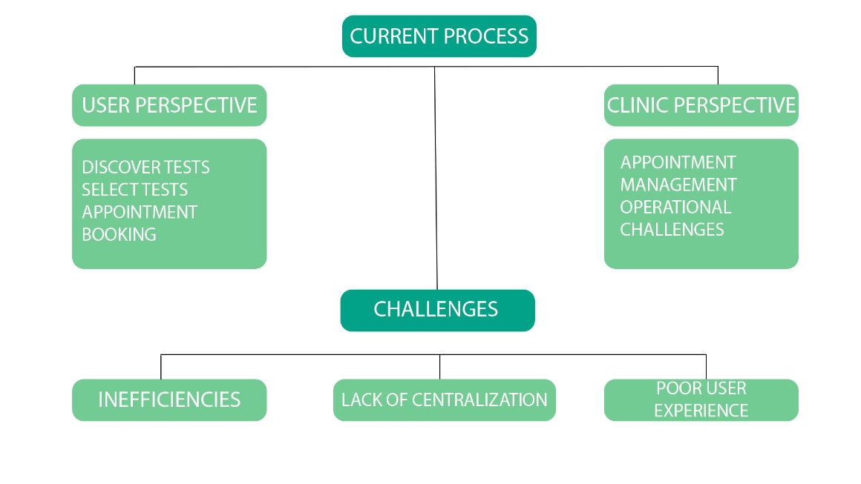

*Fig 3.1 Depiction of problem statement*

**3.3.1 Current Process:**

This represents the starting point of the current process in the PathoEase system.

**3.3.2 Discover Tests (User Perspective):**

Users initiate the process by discovering available pathology tests. This could involve browsing through a list of tests or using search functionality.

**3.3.3 Select Test (User Perspective):**

After discovering tests, users select a specific test based on their requirements. This step involves making informed decisions about the type of pathology test they need.

**3.3.4 Appointment Booking (User Perspective):**

Once users have selected a test, they proceed to book an appointment for the chosen pathology test. This step involves selecting a convenient date and time.

**3.3.5 Appointment Management (Clinic Perspective):**

Clinics take over the process at this stage, managing the appointments made by users. This includes organizing and optimizing the schedule for efficiency.

**3.3.6 Operational Challenges (Clinic Perspective):**

The clinics face operational challenges in managing appointments effectively. This could include issues related to resource allocation, time management, and overall operational efficiency.

**3.3.7 Inefficiencies (Challenges):**

The operational challenges lead to inefficiencies in the system. This may result in delays, resource wastage, and a suboptimal use of available resources.

**3.3.8 Lack of Centralization (Challenges):**

One of the core challenges is the lack of centralization in managing pathology test appointments. Information may be scattered, leading to difficulties in coordination and communication.

**3.3.9 Poor User Experience (Challenges):**

The culmination of operational inefficiencies and a lack of centralization results in a poor user experience. Users may find it challenging to navigate the system smoothly, impacting overall satisfaction.

**3.4 OBJECTIVES**

**3.4.1 Centralized Test Discovery:**

Develop a platform that centralizes information on pathology tests, making it easy for users to discover and explore the available tests. By centralizing test information, users can efficiently navigate through the variety of pathology tests offered, enhancing their experience and ensuring comprehensive test coverage.

**3.4.2 Streamlined Appointment Booking:**

Implement a user-friendly appointment booking system for pathology tests. Users should be able to seamlessly schedule appointments for their chosen tests, improving accessibility and convenience. This aims to simplify the booking process, reducing friction for both users and clinics.

**3.4.3 Efficient Appointment Management for Clinics:**

Provide clinics with tools for efficient management of pathology test appointments. Clinics need features that enable them to manage appointments, allocate resources optimally, and enhance overall operational efficiency. This objective addresses the clinic's perspective, ensuring smooth operations.

**3.4.4 Enhanced User Experience:**

Design an intuitive and user-friendly interface to enhance the overall user experience. The project aims to create an interface that is easy to navigate, ensuring a positive experience for users from test discovery to appointment booking. This involves implementing user-centric design principles.

**3.4.5 Real-Time Communication:**

Facilitate real-time communication between users and clinics regarding appointments and test-related information. This objective ensures that users and clinics can communicate effectively, reducing misunderstandings and improving the overall transparency of the appointment process.

**CHAPTER 4**

**PROPOSED WORK**

**4.1 INTRODUCTION**

PathoEase is a web application designed to simplify and expedite the process of discovering and booking pathology tests. The proposed approach aims to offer three distinctive interfaces tailored for users, pathology clinics, and an administrative portal.

**4.1.1 Efficient Test Search:**

* Advanced Search Mechanism: Implementing a robust search interface for easy test discovery.
* Real-time Suggestions: Algorithms generating instant and relevant test recommendations based on specified criteria.

**4.1.2 Enhanced User Profiles:**

* Custom Preferences: Users can input preferences, habits, and demographic information.
* Behavioral Insights: Gathering data on user behavior, interests, and medical history to create comprehensive profiles.
* Customization: Preferences for test types, medical history, age, and possibly specific health concerns.

4**.1.3 Privacy and Security Measures:**

* Strong Data Security: Employing robust encryption methods to secure user medical data.
* User Authentication: Ensuring secure login and authentication processes.
* Limited Data Sharing: Implementing measures to restrict data sharing, prioritizing user privacy.

**4.1.4 Pathology Clinic Interface:**

* Dashboard for Pathology Clinics**:** Providing a dedicated interface for clinics to manage appointments.
* Appointment Management: Allowing clinics to accept, reject, or manage appointments efficiently.
* Pathology Operations Streamlining: Supporting clinics in managing test bookings and patient information.

4.1.5 *Streamlined User Experience:*

* Intuitive Interface: Designing a user-friendly interface for seamless navigation.
* Responsive Design: Ensuring compatibility across various devices for accessibility.

**4.2** **PROPOSED METHODOLOGY**

Step 1: Data Collection and User Profiling

Step 2: Data Pre-processing

Step 3: Feature Selection

Step 4: Algorithm Selection

Step 5: Matching and Compatibility Calculation

Step 6: Privacy Implementation

Step 7: Testing and Validation

Step 8: Optimization and Refinement

Step 9: Deployment and Monitoring

**4.3 DESCRIPTION OF EACH STEP**

**Step 1: User Data Acquisition and Profile Building**

Collect comprehensive user data including medical history, test preferences, and demographics to construct detailed user profiles.

**Step 2: Data Preparation and Cleaning**

Cleanse and pre-process collected data to ensure accuracy and consistency for further analysis.

**Step 3: Key Feature Identification**

Select pivotal user profile attributes and pathology clinic data features crucial for accurate test recommendations.

**Step 4: Algorithmic Framework Selection**

Choose appropriate algorithms to match user profiles with pathology clinic services effectively.

**Step 5: Compatibility Assessment and Match Generation**

Implement algorithms to assess compatibility and generate tailored pathology test recommendations based on user profiles.

**Step 6: Data Security and Privacy Measures**

Implement stringent privacy protocols, including robust encryption and secure authentication, to safeguard user and clinic data.

**Step 7: Rigorous Testing and Validation**

Conduct comprehensive testing to validate the accuracy and reliability of pathology test recommendations and user-pathology clinic matches.

**Step 8: Iterative Refinement and Optimization**

Refine the recommendation system based on user feedback and performance metrics to enhance accuracy and usability continually.

**Step 9: Platform Deployment and Continuous Monitoring**

Launch the finalized platform and establish continuous monitoring systems to ensure data security, reliability, and ongoing optimization.

**CHAPTER 5**

**SYSTEM DESIGN**

**5.1 FUNCTIONAL SPECIFICATIONS**

**5.1.1 Level 0 DFD**

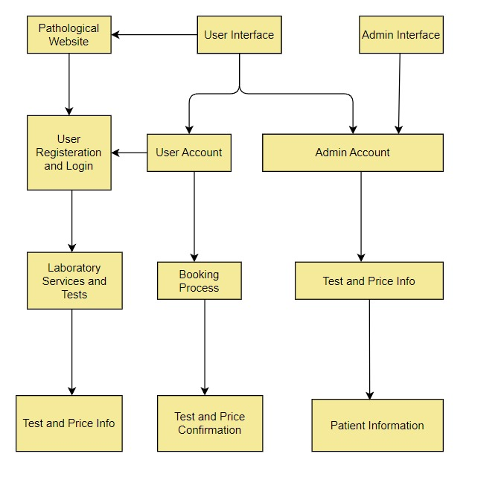

*Fig 5.1 Level 0 DFD*

**5.1.2 Higher Level DFD**

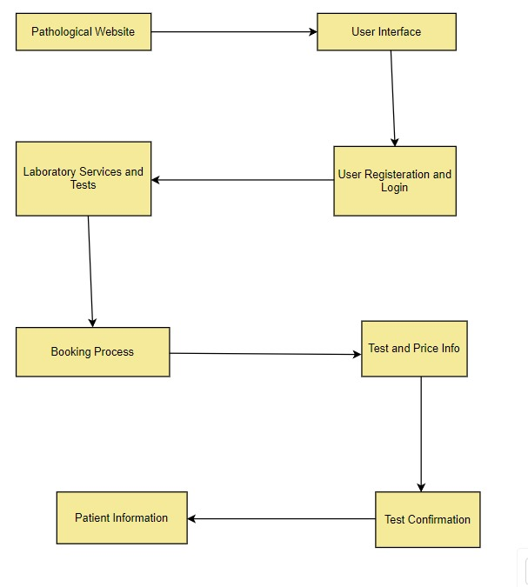

*Fig 5.2 Higher Level DFD*

**5.2 STRUCTURAL AND DYNAMIC MODELLING OF SYSTEM**

**5.2.1 Class Diagram:**

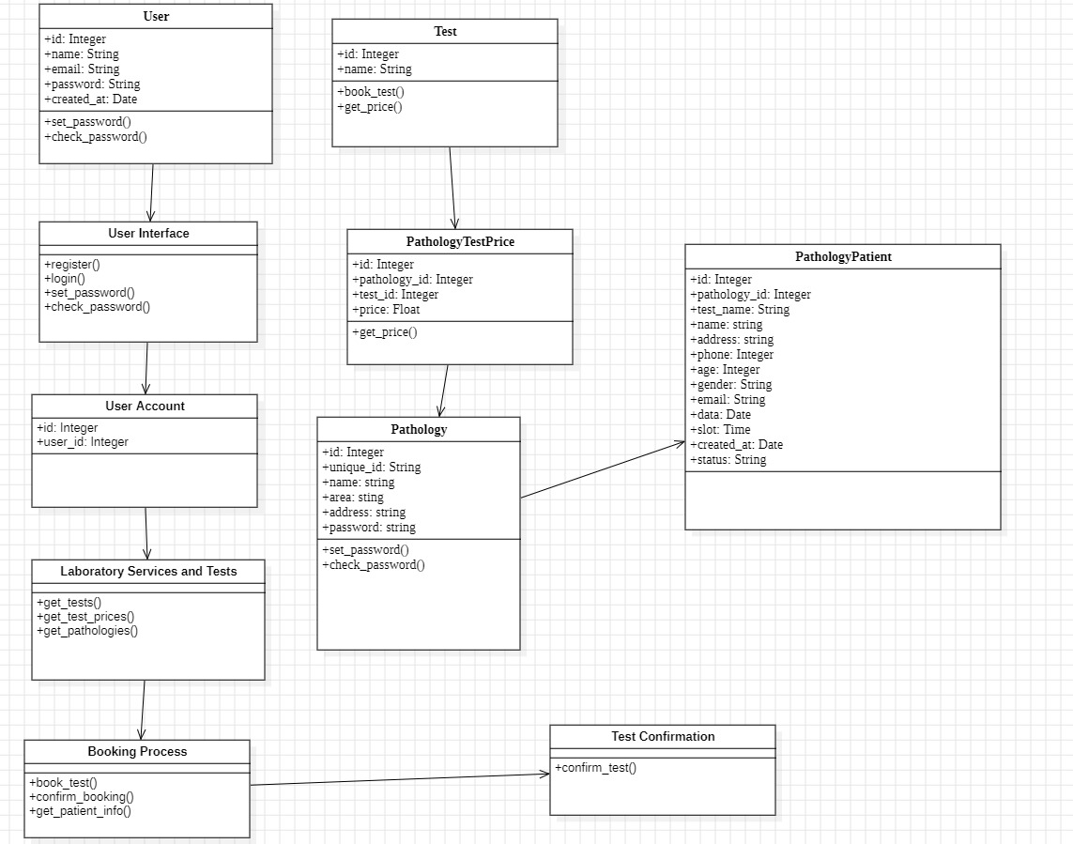

*Fig 5.3 Class Diagram*

**5.2.2 Use Case Diagram**

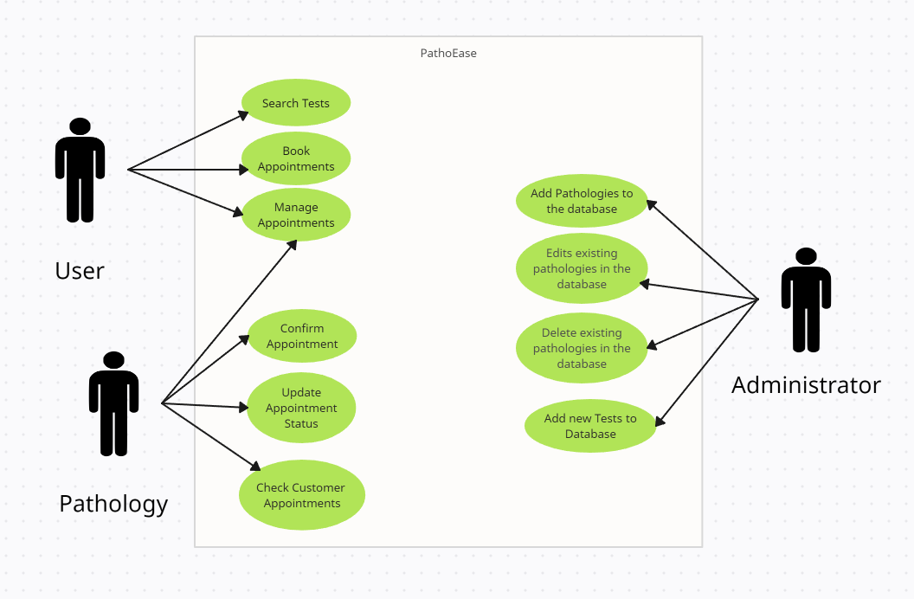

*Fig 5.4 Use Case Diagram*

**5.2.3 Interaction Diagram**

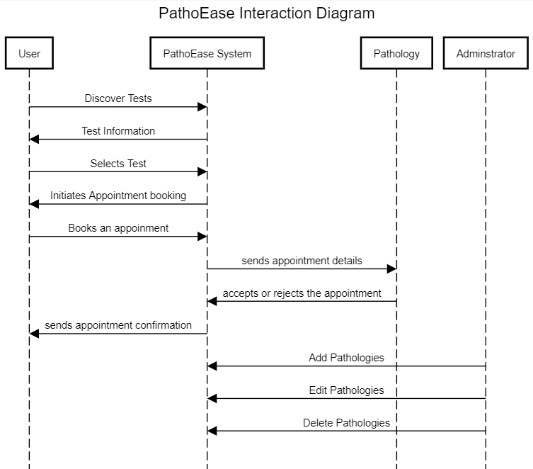

*Fig 5.5 Interaction Diagram*

**5.2.4 State/Activity Diagram**

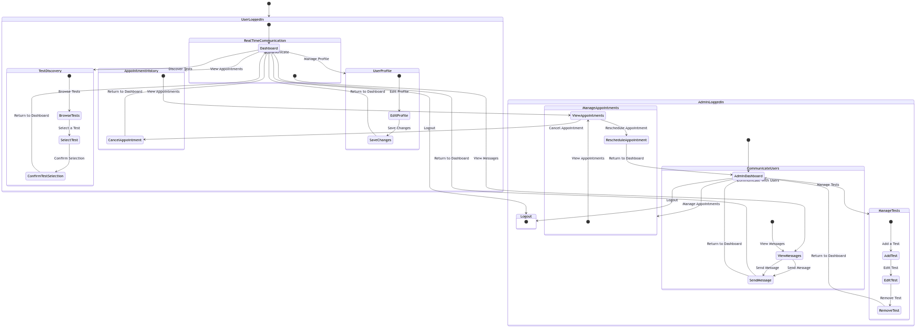*Fig 5.6 State/Activity Diagram*

**5.3 DETAIL BLOCK DIAGRAM**

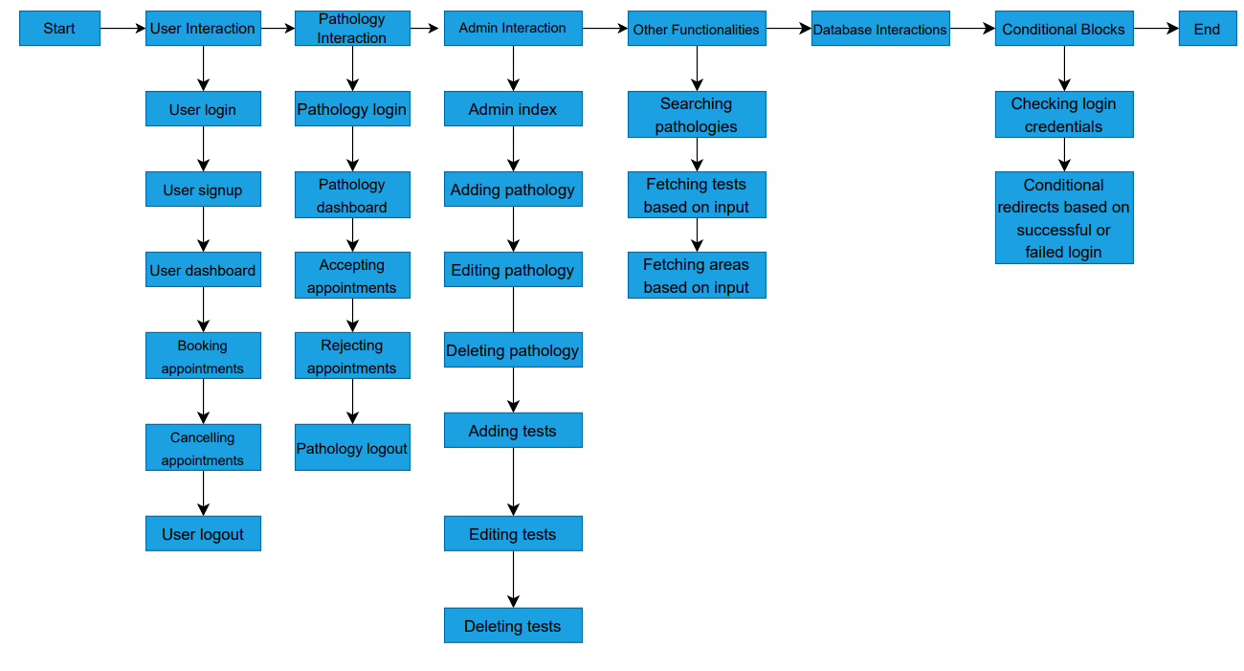

*Fig 5.7 Block Diagram*

**CHAPTER 6**

**IMPLEMENTATION**

**6.1 EXPERIMENTAL SETUP**

**6.1.1 Techniques Used**

**Bcrypt**

Bcrypt is utilized as a secure password hashing algorithm to enhance the protection of user credentials stored in the system. Bcrypt, short for "Blowfish crypt," is a widely used and well-regarded cryptographic hash function designed specifically for password hashing. It employs adaptive hash functions based on the Blowfish cipher, making it resistant to brute-force attacks and other common cryptographic vulnerabilities.

Here's how Bcrypt is beneficial in the PathoEase project:

1. Password Security:

Bcrypt is chosen for its ability to securely hash passwords. When a user creates an account or updates their password, Bcrypt hashes the password before storing it in the database. The hashed password is a complex, one-way transformation of the original password, making it computationally infeasible for attackers to reverse the process and obtain the original password.

2. Resistance to Brute-Force Attacks:

Bcrypt incorporates a cost factor or "work factor," which controls the computational complexity of the hashing algorithm. This feature ensures that even with advancements in computing power, brute-force attacks against hashed passwords remain resource-intensive and time-consuming, significantly enhancing the security of stored credentials.

3. Salting:

Bcrypt automatically handles the generation and management of salts. A salt is a random data unique to each user, combined with their password before hashing. Salting adds an additional layer of security by preventing attackers from using precomputed tables (rainbow tables) for password cracking.

4. Adaptability:

Bcrypt is designed to be adaptable, allowing the cost factor to be easily increased over time. This adaptability ensures that the hashing algorithm can evolve to withstand emerging threats and advancements in computational power.

5. Open-Source and Widely Adopted:

Bcrypt is an open-source algorithm with a proven track record of security. Its widespread adoption in the industry, including in frameworks like Django for Python and bcrypt-ruby for Ruby, attests to its reliability and effectiveness.

**SQLAlchemy**

SQLAlchemy is a powerful and widely used SQL toolkit and Object-Relational Mapping (ORM) library for Python. In the PathoEase project, SQLAlchemy might be employed to interact with the project's database, providing a high-level, Pythonic interface for database operations.

Here's how SQLAlchemy is utilized in the PathoEase project:

**ORM for Database Interaction:**

SQLAlchemy allows developers to interact with databases using Python objects instead of writing raw SQL queries. This is achieved through the use of an ORM, where Python classes are mapped to database tables, and instances of these classes represent individual database records. SQLAlchemy's ORM capabilities are leveraged to model pathology tests, user data, appointments, and other relevant entities in the system. This abstraction simplifies database interactions and promotes cleaner, more maintainable code.

**Database Abstraction and Flexibility:**

SQLAlchemy supports multiple relational database management systems (RDBMS) and provides a unified interface for interacting with them. This abstraction allows developers to write database-agnostic code and switch between different database engines seamlessly. If the project evolves or requires integration with different databases, SQLAlchemy's flexibility allows for a smoother transition. This is beneficial for future-proofing the application and adapting to changing requirements.

**Query Construction and Execution:**

SQLAlchemy provides a powerful SQL expression language that allows developers to construct complex queries using Pythonic syntax. It also facilitates the execution of these queries, making database interactions more expressive and efficient. Complex queries related to test discovery, appointment scheduling, and user interactions are constructed using SQLAlchemy's query-building capabilities. This ensures that database operations are performed efficiently and accurately.

**Transaction Management:**

SQLAlchemy supports transactions, allowing developers to group multiple database operations into a single unit of work. Transactions ensure data consistency and integrity, and they can be rolled back in case of errors. During critical operations, such as appointment scheduling or updating user information, transactions can be employed to maintain the consistency of the database. If any part of the operation fails, the entire transaction can be rolled back to its original state.

**Connection Pooling:**

SQLAlchemy includes built-in connection pooling, which helps manage and reuse database connections efficiently. Connection pooling is crucial for handling multiple simultaneous database requests without creating a new connection for each request. In scenarios where, multiple users are interacting with the system concurrently, connection pooling helps optimize resource usage and improve overall system performance.

**6.1.2 Software Tools Used**

**Programming Language: Python**

Python serves as the primary programming language for developing the PathoEase application. Known for its readability and versatility, Python enables efficient development, making it a popular choice for web applications.

**Web Framework: Flask**

Flask is a lightweight and modular web framework for Python. It facilitates the development of web applications by providing essential features and extensions. Flask is chosen for its simplicity and ease of integration with other tools.

**Database Management System: SQLite**

SQLite is a self-contained, serverless, and zero-configuration relational database management system. It is used in PathoEase to manage and organize data related to pathology tests, appointments, and user information.

**Object-Relational Mapping (ORM): SQLAlchemy**

SQLAlchemy is a Python ORM that simplifies database interactions by allowing developers to work with databases using Python objects. It provides an abstraction layer over relational databases, making it easier to manage and query data.

**Frontend Development: HTML, CSS, JavaScript**

Description: For the frontend development of the user interface, standard web technologies such as HTML, CSS, and JavaScript are used. These technologies enable the creation of a responsive and user-friendly interface for users interacting with the PathoEase platform.

**Web Template Engine: Jinja2**

Description: Jinja2 is a templating engine for Python, used with the Flask framework. It allows for the dynamic generation of HTML pages, making it easier to integrate data from the backend into the frontend views.

**IDE (Integrated Development Environment): VS Code**

Description: Visual Studio Code (VS Code) is a popular open-source code editor. It supports various programming languages, offers extensions for Flask development, and provides a user-friendly interface for coding, debugging, and version control.

**6.2 PATHOEASE OUTLOOK**

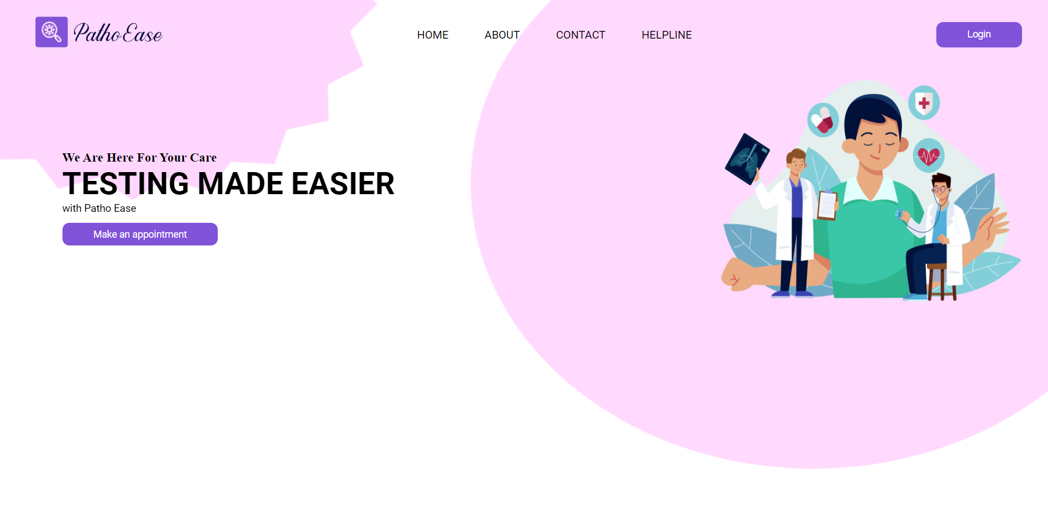

*Fig 6.1 Home Page*

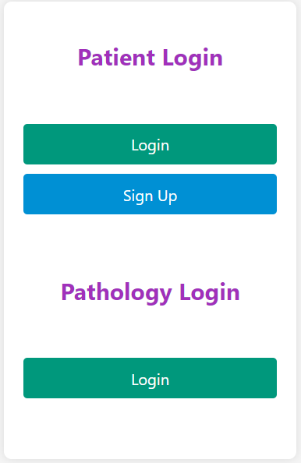

*Fig 6.2 Main Login Page*

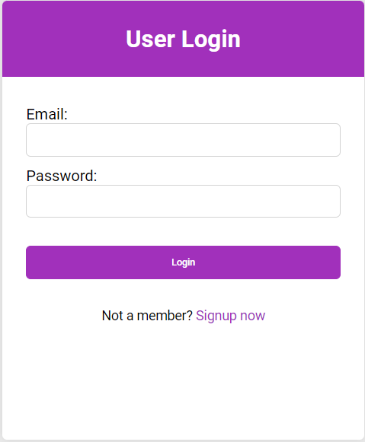

*Fig 6.3 User Login Page*

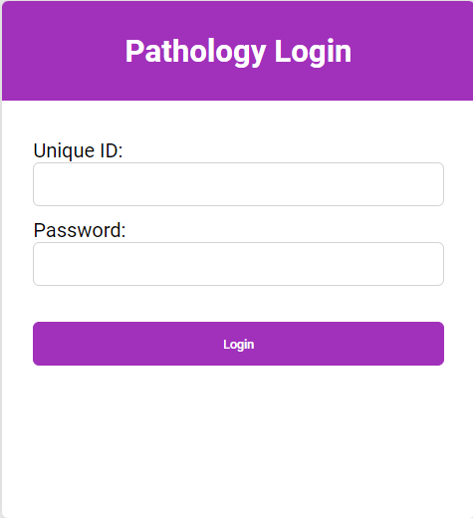

*Fig 6.4 Pathology Login Page*

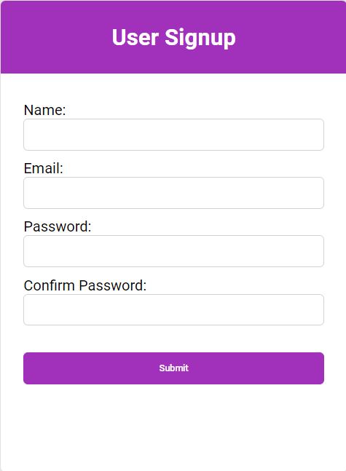

*Fig 6.5 User Signup Page*

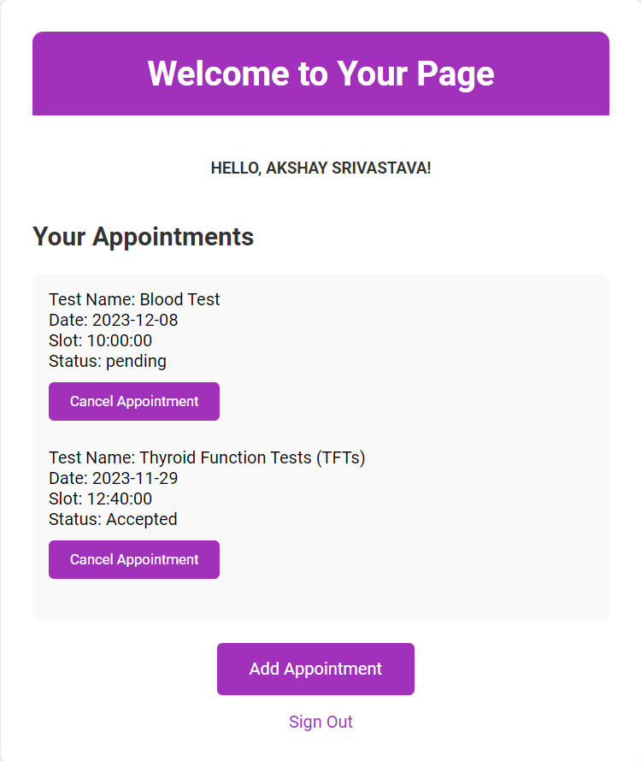

*Fig 6.6 User Home Page*

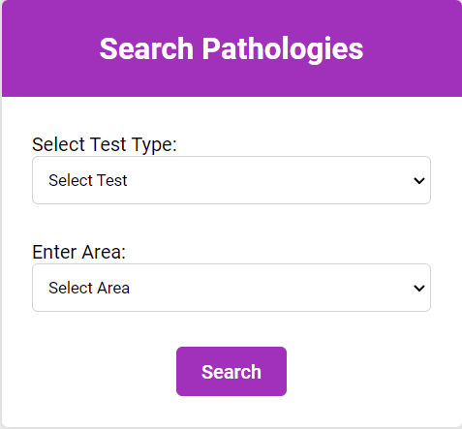

*Fig 6.7 Search Pathologies Page*

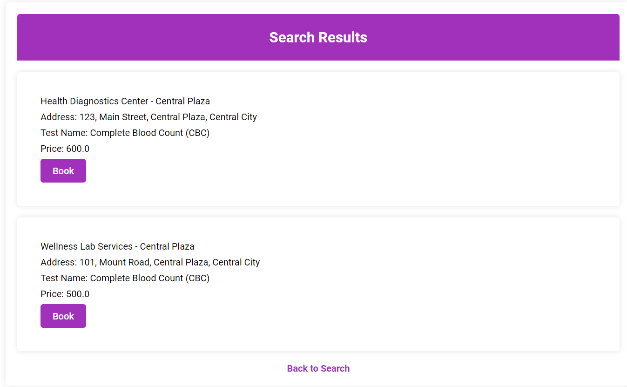

*Fig 6.8 Search Results Page*

**CHAPTER 7**

**RESULT ANALYSIS**

**7.1 PERFORMANCE MEASURES**

Performance measures for the PathoEase project can be categorized into several key areas, each reflecting different aspects of the system's functionality, efficiency, and user satisfaction. Here are performance measures for the project:

**7.1.1 Response Time:**

Objective: Ensure that the platform provides quick responses to user interactions.

Measure: Average response time for actions such as test discovery, appointment scheduling, and information retrieval.

**7.1.2 System Availability:**

Objective: Maintain high availability to ensure users can access the platform when needed.

Measure: Percentage of time the system is operational without disruptions or downtime.

**7.1.3 User Adoption Rate:**

Objective: Assess the extent to which users are actively using the platform.

Measure: Number of new user registrations, frequency of logins, and engagement with different features.

**7.1.4 Error Rate:**

Objective: Minimize errors and disruptions during user interactions.

Measure: Percentage of transactions or interactions that result in errors, system crashes, or unexpected behaviour.

**7.1.5 Appointment Scheduling Efficiency:**

Objective: Ensure that the appointment scheduling process is streamlined.

Measure: Time taken for users to complete the appointment scheduling process, from test selection to confirmation.

**7.1.6 User Satisfaction:**

Objective: Evaluate user satisfaction with the platform's usability and features.

Measure: Conduct regular user surveys or feedback sessions to gather user opinions and ratings.

**7.1.7 Test Discovery Coverage***:*

Objective: Ensure that the platform covers a comprehensive range of pathology tests.

Measure: Percentage of commonly sought-after tests available on the platform compared to the total possible test categories.

**7.1.8 Real-time Communication Effectiveness:**

Objective: Facilitate efficient communication between users and clinics.

Measure: Evaluate the responsiveness and effectiveness of real-time communication channels, including notifications and messaging.

**7.1.9 Security and Privacy Compliance:**

Objective: Ensure that the platform adheres to security and privacy standards.

Measure: Compliance with healthcare data protection regulations, including HIPAA, and the absence of security vulnerabilities.

**7.1.10 Scalability***:*

Objective: Assess the platform's ability to handle increased load as user numbers grow.

Measure: Performance under stress testing scenarios, including the ability to handle a higher volume of concurrent users and appointments.

**7.1.11 Cost Efficiency:**

Objective: Optimize resource utilization to manage operational costs effectively.

Measure: Evaluate the platform's efficiency in resource utilization, including server costs, storage, and maintenance.

**CHAPTER 8**

**CONLCUSION AND FUTURE SCOPE**

**8.1 CONCLUSION**

In conclusion, the PathoEase project represents a significant milestone in addressing the intricate challenges within the landscape of pathology test access and scheduling. The journey embarked upon in this project report reflects a thorough exploration of the existing healthcare ecosystem, uncovering inefficiencies and complexities that hinder the seamless interaction between users and clinics.

The development and implementation of the PathoEase platform stand as a testament to our commitment to creating a transformative solution. Centralizing test information, streamlining appointment processes, and fostering real-time communication have been the core pillars of this endeavour. Through meticulous design, technological innovation, and a user-centric approach, the project seeks to redefine the user experience, making it more accessible, efficient, and satisfying.

As we reflect on the objectives achieved, from enhancing user experience to providing efficient appointment management tools for clinics, it becomes evident that PathoEase has the potential to revolutionize how pathology tests are accessed and scheduled. The project not only meets the identified needs but also lays the groundwork for future innovations and advancements in the realm of healthcare technology.

In the broader context of healthcare, the PathoEase project aligns with the global shift towards digitalization and user-centric healthcare services. It opens avenues for increased efficiency, better resource allocation, and improved patient outcomes. The lessons learned, challenges overcome, and innovations introduced throughout this project contribute not only to the field of pathology but also serve as a blueprint for similar advancements in other healthcare domains.

In essence, the PathoEase project report encapsulates the collective efforts, insights, and dedication of the project team. It signifies more than just the culmination of technical tasks; it represents a commitment to improving lives, streamlining processes, and contributing to the ever-evolving landscape of healthcare technology. The successful execution of this project lays the foundation for a future where accessing pathology tests is not only a necessity but a seamless and empowering experience for all stakeholders involved.

**8.2 FUTURE SCOPE**

The future scope of the PathoEase project is expansive and holds the potential for continued growth and impact in the healthcare technology landscape. Some key avenues for future development and enhancement include:

**8.2.1 Integration with Electronic Health Records (EHR):**

Collaborating with existing healthcare systems to integrate PathoEase with Electronic Health Records can provide a holistic view of a patient's health history. This integration would contribute to better-informed decision-making and improved continuity of care.

**8.2.2 Machine Learning and Predictive Analytics:**

Implementing machine learning algorithms can enhance the platform's ability to predict user preferences, optimize appointment scheduling, and provide personalized recommendations. This predictive analytics approach can contribute to a more proactive and tailored healthcare experience.

**8.2.3 Expansion of Test Offerings and Geographical Reach:**

Continuously expanding the range of pathology tests offered on the platform and extending its reach to different geographical locations would ensure that a diverse range of users can benefit from the centralized and user-friendly approach to pathology test access and scheduling.

**8.2.4 Mobile Application Development:**

Developing a dedicated mobile application can further enhance accessibility, allowing users to discover tests, schedule appointments, and receive notifications conveniently from their mobile devices. This can cater to the growing trend of mobile-centric healthcare solutions.

**8.2.5 Telemedicine Integration:**

Integrating telemedicine features can enable virtual consultations, result discussions, and follow-up appointments. This integration would add a layer of convenience for both users and healthcare providers, especially in situations where physical visits may be challenging.

**8.2.6 Blockchain for Security and Transparency:**

Exploring blockchain technology for enhanced security and transparency in managing patient data and appointment records can address concerns related to data integrity and privacy, instilling greater confidence in users and clinics alike.

**8.2.7 User Feedback and Iterative Design:**

Establishing a robust feedback mechanism and adopting an iterative design approach based on user input will be crucial for keeping the platform aligned with evolving user expectations and technological advancements.

**8.2.8 Collaboration with Healthcare Institutions:**

Forming strategic partnerships with healthcare institutions, clinics, and diagnostic laboratories can lead to a more comprehensive and interconnected healthcare ecosystem. This collaboration can foster seamless data exchange and interoperability.

**8.2.9 Regulatory Compliance:**

Staying abreast of evolving healthcare regulations and ensuring compliance with standards such as Health Insurance Portability and Accountability Act (HIPAA) will be essential for maintaining data security and user trust.

The future scope of the PathoEase project envisions a dynamic and evolving platform that adapts to emerging technologies, user needs, and industry trends. By embracing continuous innovation and collaboration, PathoEase can play a pivotal role in shaping the future of accessible and efficient healthcare services.

**REFERENCES**

1. *Kim, P. et al. (1999) Published criteria for Evaluating Health Related Web sites: Review, The BMJ. Available at: https://www.bmj.com/content/318/7184/647.1 (Accessed: 12 December 2023).*

2. *Coiera, E. (1996) The Internet’s Challenge to health care provision, The BMJ. Available:https://www.bmj.com/content/312/7022/3?ijkey=287d1daafba0561f2962ee30bd34863990b3618a&amp;keytype2=tf_ipsecsha (Accessed: 12 December 2023).*

3. *Book lab test online V/s visiting offline-modern diagnostic (2023) Modern Diagnostic Lab. Available at: http://www.moderndiagnosticlabs.com/blog/book-lab-test-online/ (Accessed: 06 December 2023).*

4. *Jadad AR, Gagliardi A. Rating health information on the internet. Navigating to knowledge or to Babel? JAMA 1998;279:611–614*

5. *Bowen JW, Klimczak JC, Ruiz M, Barnes M. Design of access control methods for protecting the confidentiality of patient information in networked systems. Proceedings of the American Medical Informatics Association annual fall symposium 1997:46-50*

*6.Weale S., Surfer, heal thyself. Guardian 1995 Sept 20:13.*

7. *Python 3.12.1 documentation*. Available at: https://docs.python.org/3/ (Accessed: 13 December 2023).

8. *Official Flask Documentation Welcome to Flask - Flask Documentation (3.0.x). Available at: https://flask.palletsprojects.com/en/3.0.x/ (Accessed: 13 December 2023).*

9. *Sqlachemy Flask Available at: https://flask-sqlalchemy.palletsprojects.com/en/3.1.x/ (Accessed: 13 December 2023).*

10. *WTForms Flask. Available at: https://flask-wtf.readthedocs.io/en/1.2.x/ (Accessed: 13 December 2023).*

11. Bcrypt Flask. Available at: https://flask-bcrypt.readthedocs.io/en/1.0.1/ (Accessed: 13 December 2023).